

Name:
Tehreem Mirza

Registeration No:
FA22-BSE-088

Section:
BSE-8B

Submitted To:
Mam Mehwish

Task: Performed all Jira feature

STEP 1: Epic : Task is created to represent a major module of the system.
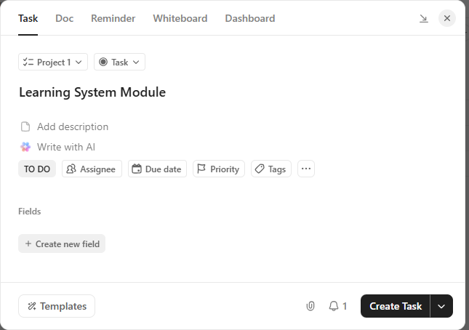

STEP 2: Urgent Task : An urgent task is created with high priority to highlight critical work.
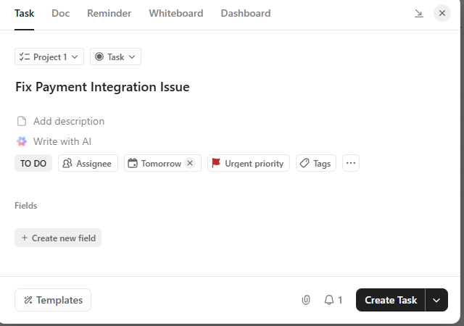

Step 3: Story : A story task is created with assigned user, due date, and priority.
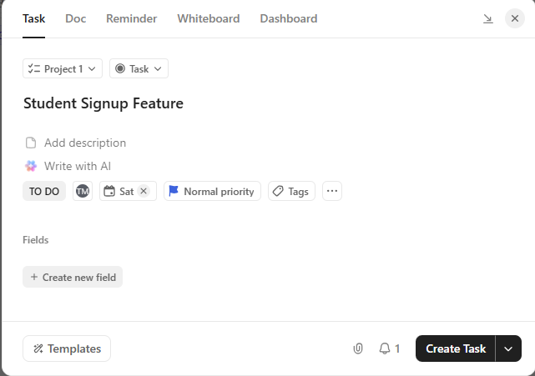

Step 4: Task details are updated with description, checklist, and comments.
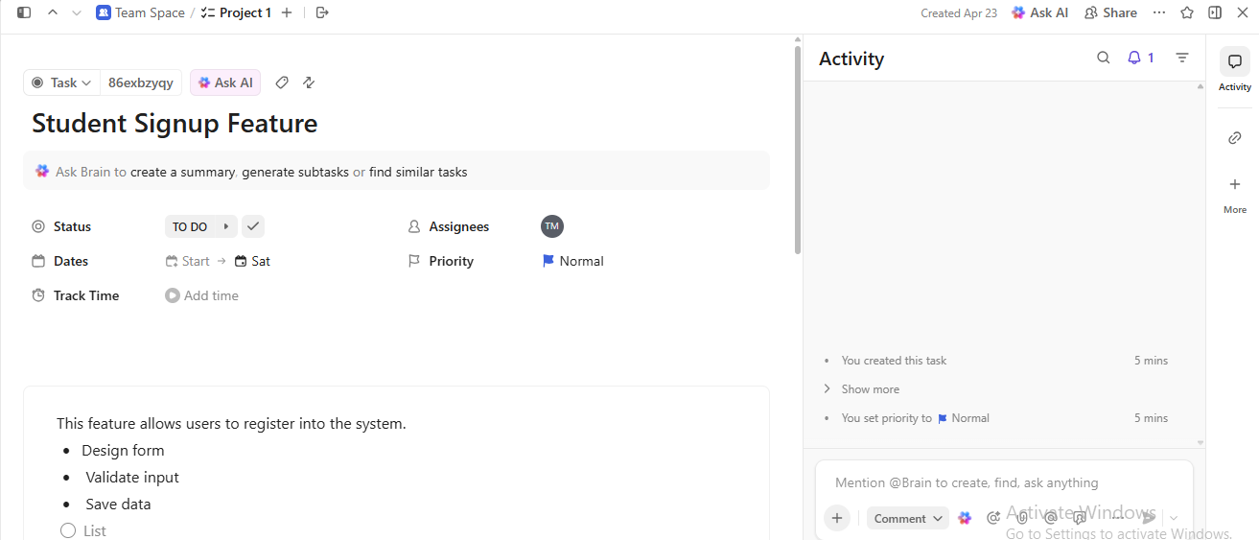

Step 5: Task status is changed from To Do to Done to show workflow progress.
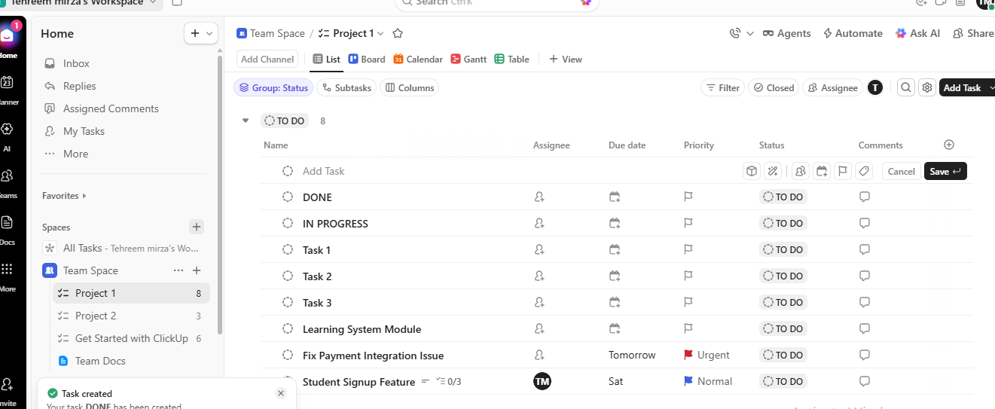
Step 6 : Board view displays tasks across different stages of the workflow.


